**Load Data from ADLS Gen 1 to ADLS gen 2 guide**

Create a new Azure Data Factory

Click on “Author and Monitor”

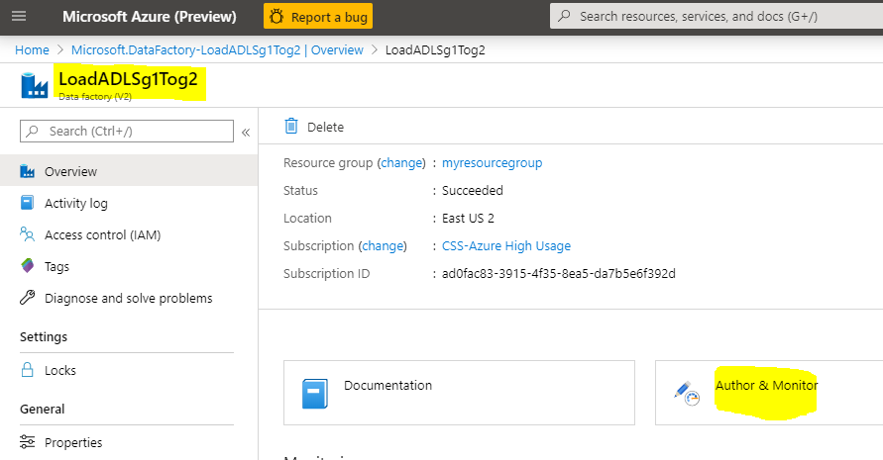

Click on “Copy Data”

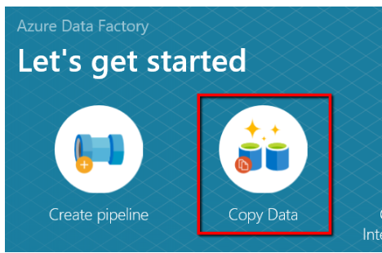

You will be prompt to filled in some information

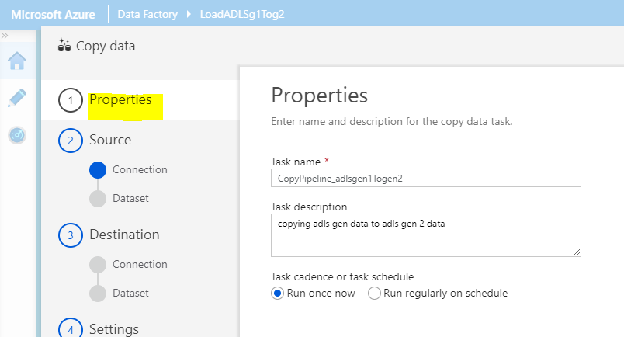

Next > Source > create new connection > ADLS gen 1

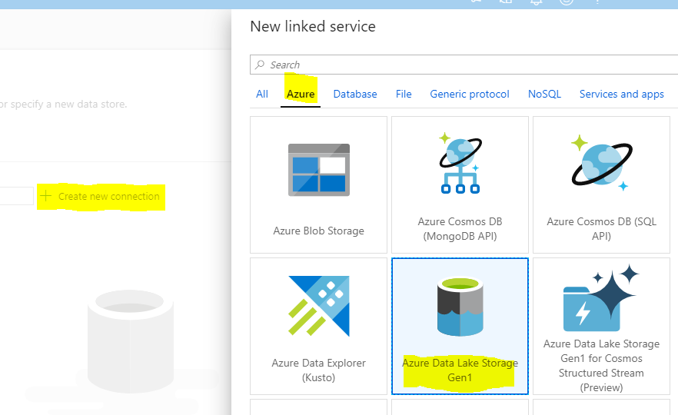

Once you configured and you meet a “permission issue” follow the below to steps

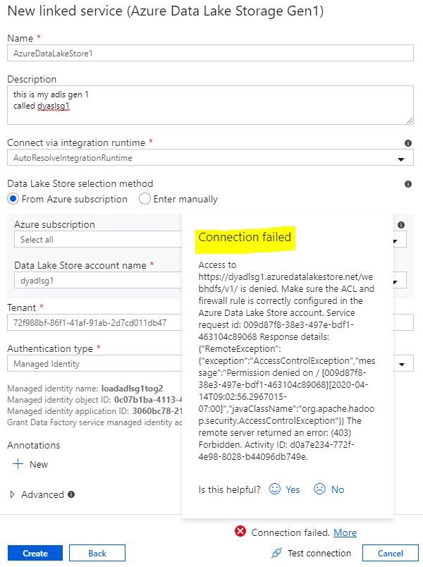

Then follow this step to fix the permission access issue:

Go to your ADLS gen 1

dyadlsg1 > Data lake storage gen 1 > Data explorer

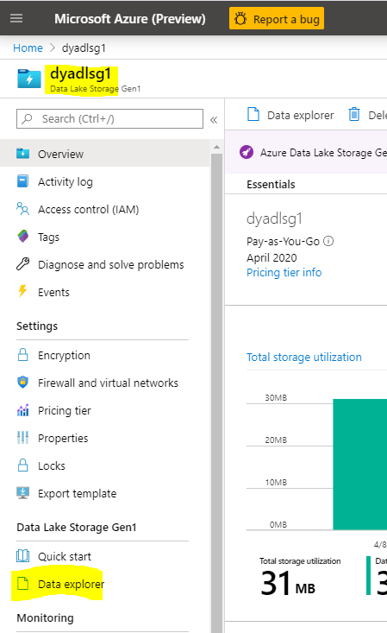

Click on “Access”

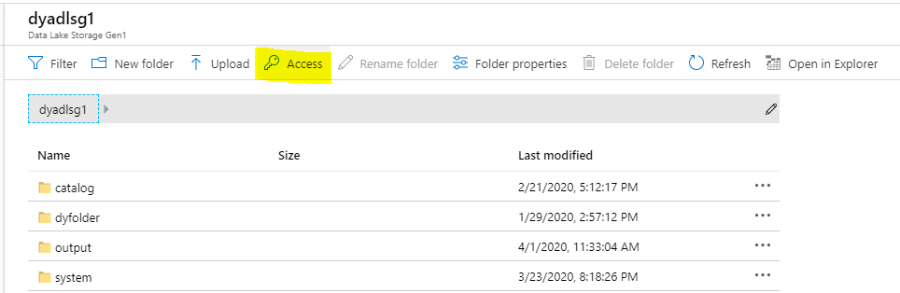

Then manually input the Azure Data Factory to have access to your ADLS gen 1

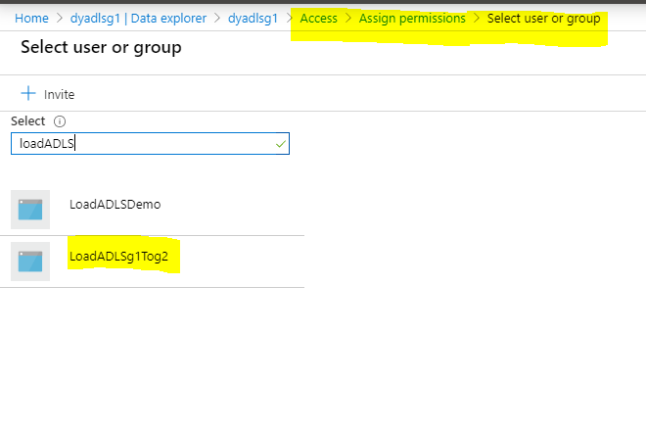

Next select the permission you want to assigned (You don’t have to follow my configure on the permission)

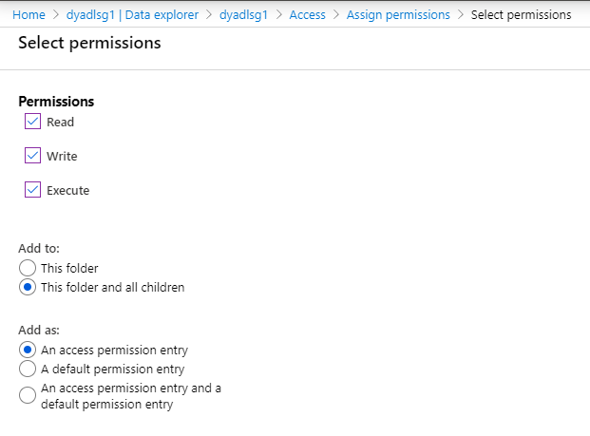

Once you are done you should see the new added Data factory added

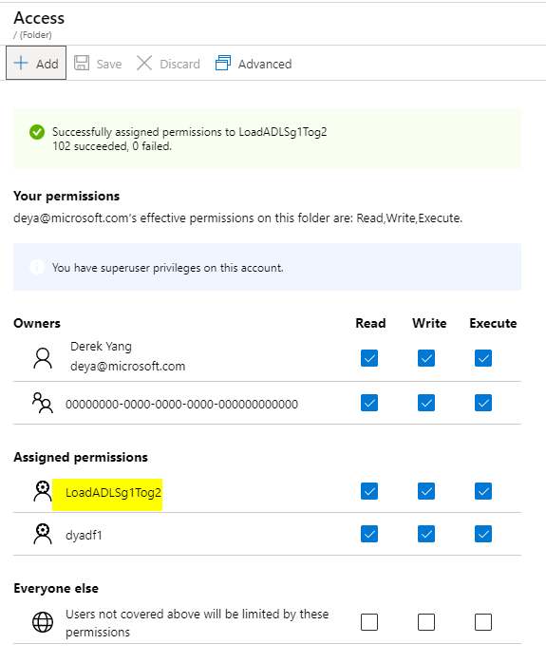

*Adding permission to your ADF to have access to your ADLS gen 1 ends here*

Now go back to your setup in Azure Data Factory

Continue configuring the “Source”

Now you won’t see this error anymore

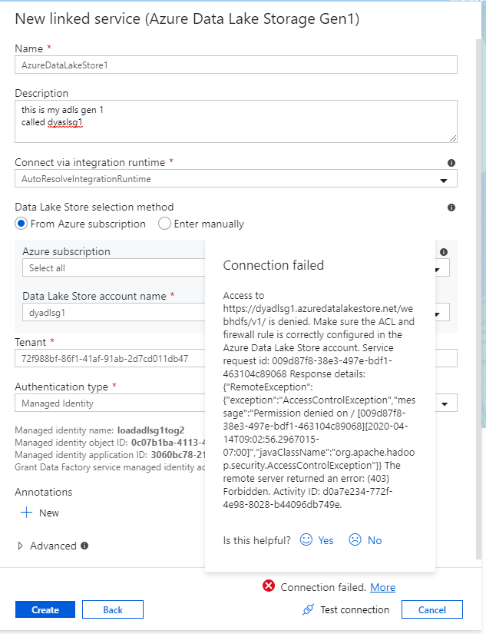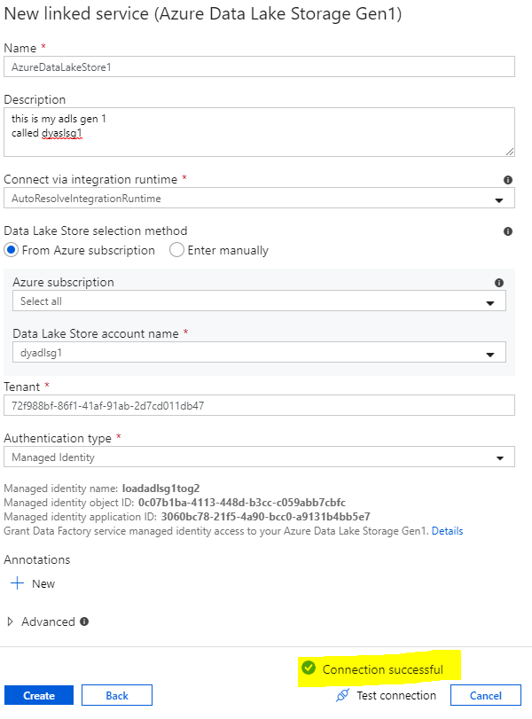

Click on “Test Connection” again

The connection should be successful.

Click “create”

Next configure the Data set in your ADLS gen 1 you need to copy to the ADLS gen 2

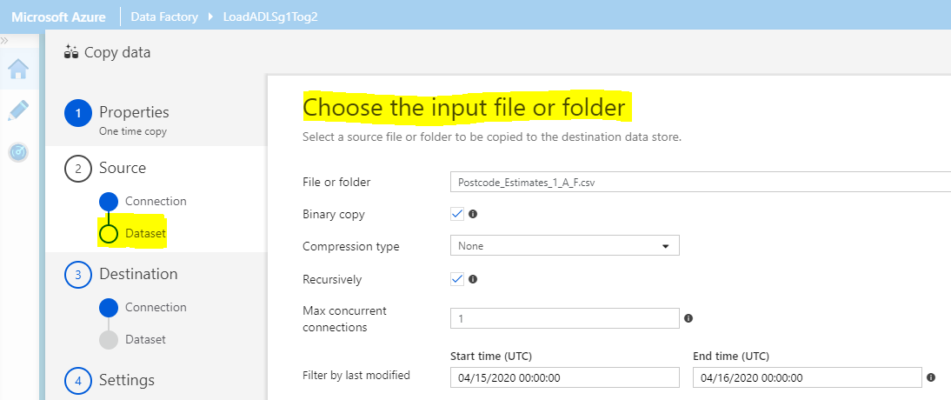

This will prompt you back to now configure the next step “Destination”

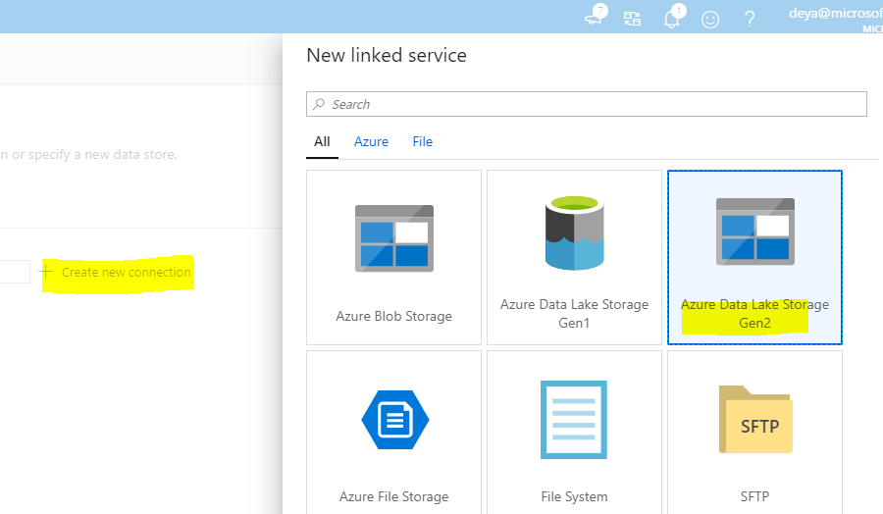

Configured your ADLS gen2

Make sure to “test connection”

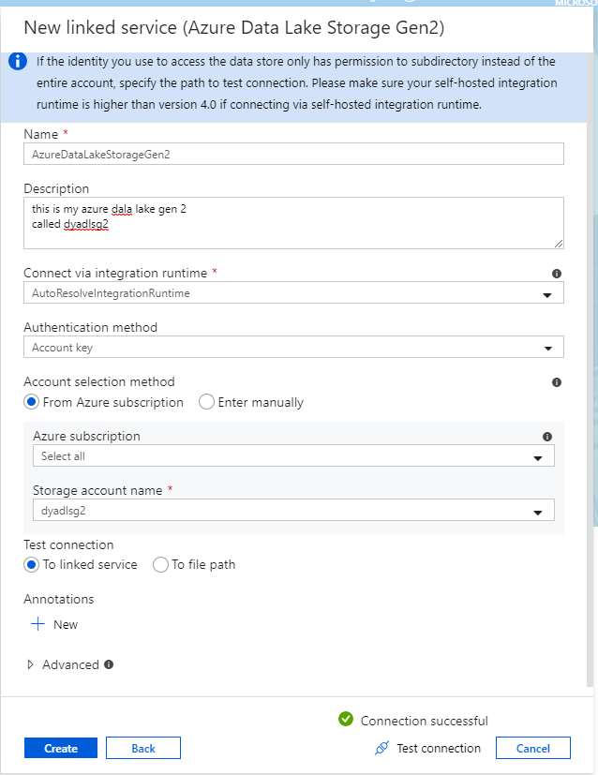

Now configure the output path

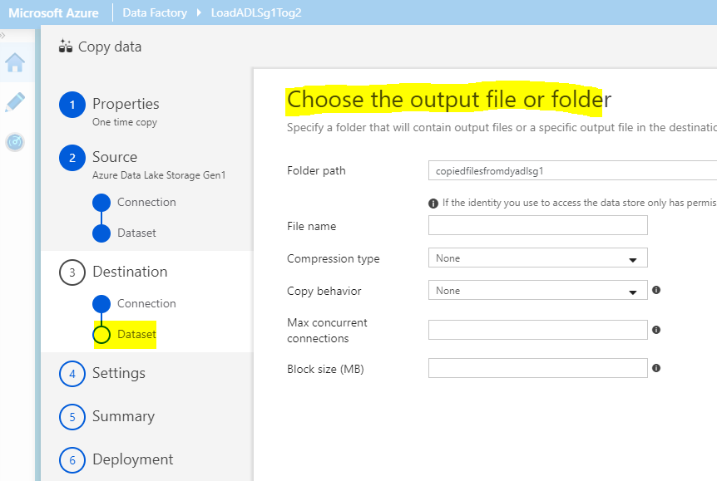

Review your configurations

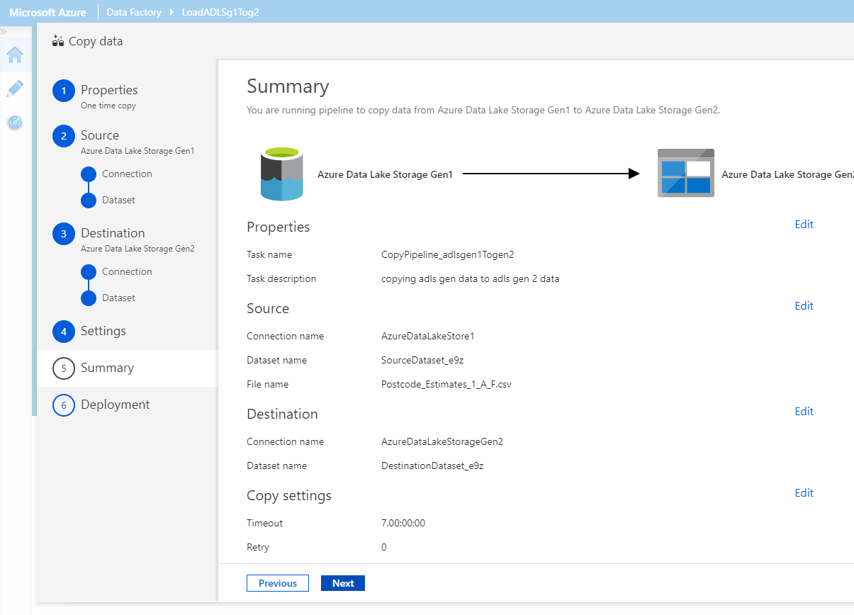

Click next to run the job.

Once the data is copied you will be complete.

You can view the monitor and or the detailed as suggested in the link I will send to your through email and I will also share it below:

<https://docs.microsoft.com/en-us/azure/data-factory/load-azure-data-lake-storage-gen2-from-gen1>